Practical 3
Aim:- Implement control structures and form validation; create a grading system based on user-entered marks.
Software/Tools Required: VS Code , Web Browser
Experiment program code:
Student Marks and grade:-

<html>
<head>
<title>Sanvi Wadhankar</title>
</head>
<body>
<h2>Sanvi wadhankar 1191</h2>
<h2>Student Grading System</h2>
<h3>Enter marks:</h3>
<input type = 'number' id = 'marks'></input>
<button onClick="checkGrade()">Submit</button>
<p id = 'result'></p>
<script>
function checkGrade(){
var marks = document.getElementById("marks").value;
if( marks == ""){
alert("Please Enter marks!!");
return;
}
if(marks<0 || marks> 100){
alert("Enter marks between 0 and 100");
}
if(marks>=90){
grade = 'A';
}
else if(marks >=80){
grade = "B";
}
else if(marks>=70){
grade = "C";
}
else if(marks >=50){
grade = "D"
}
else{
grade = "Fail";
}
document.getElementById("result").innerHTML =
"Marks =" + marks + "<br>Grade = "+ grade;

}
</script>

</body>
</html>

Output:-
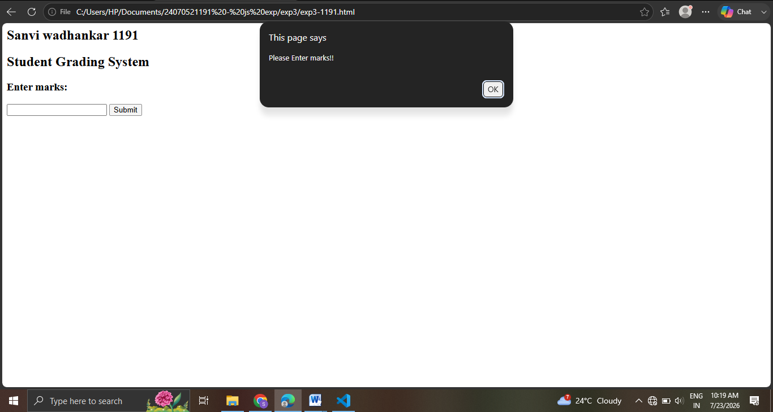
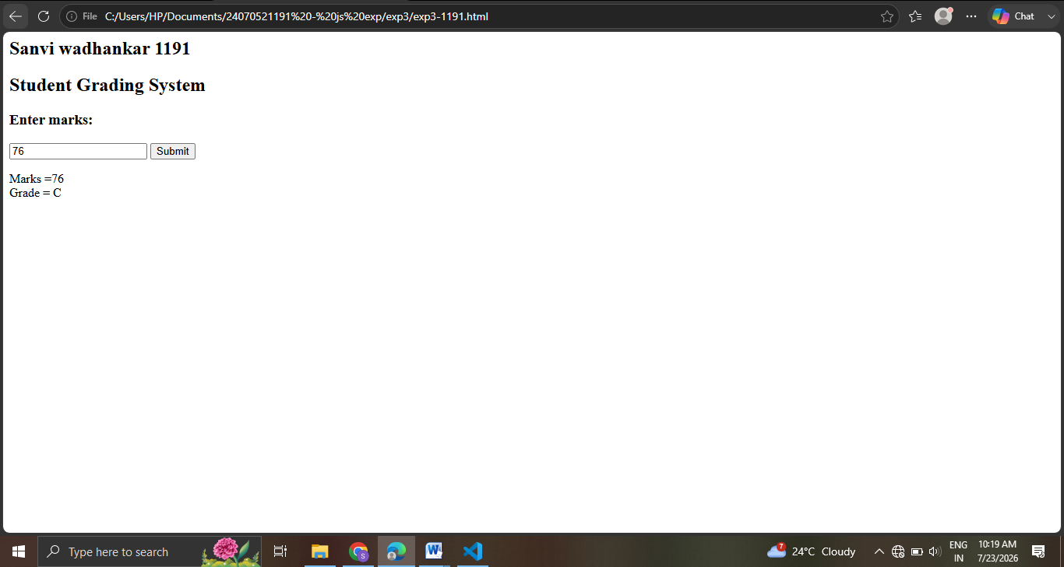
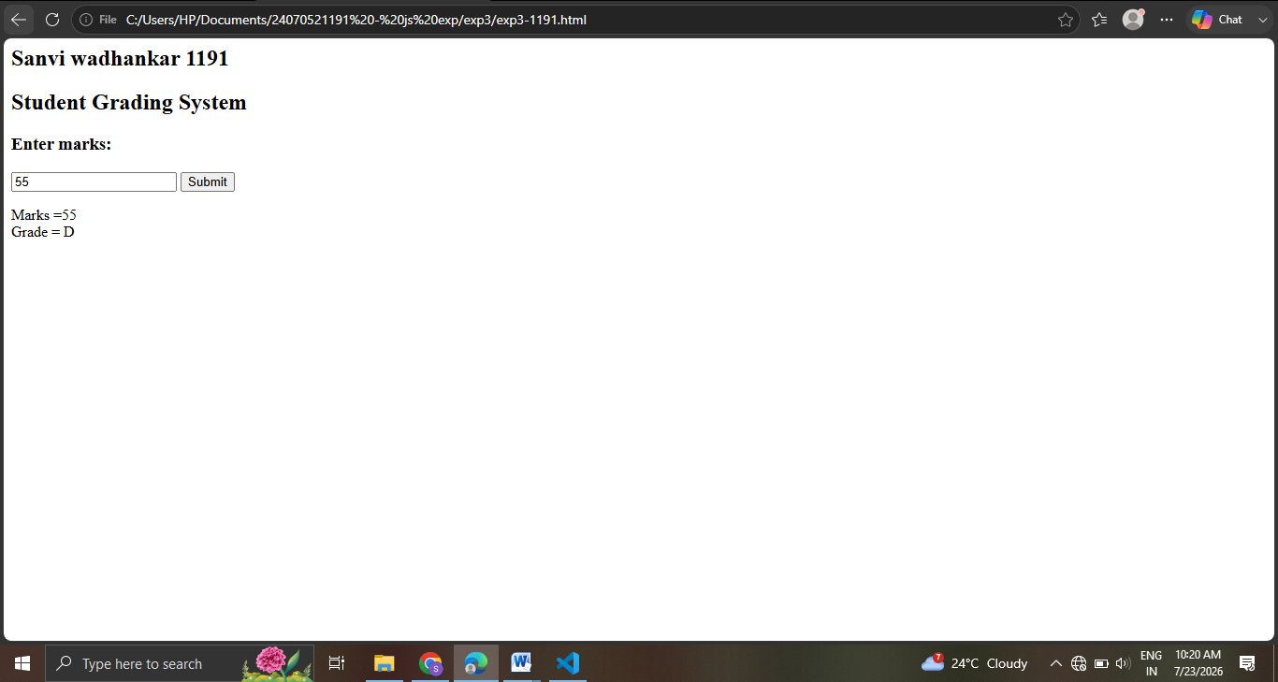
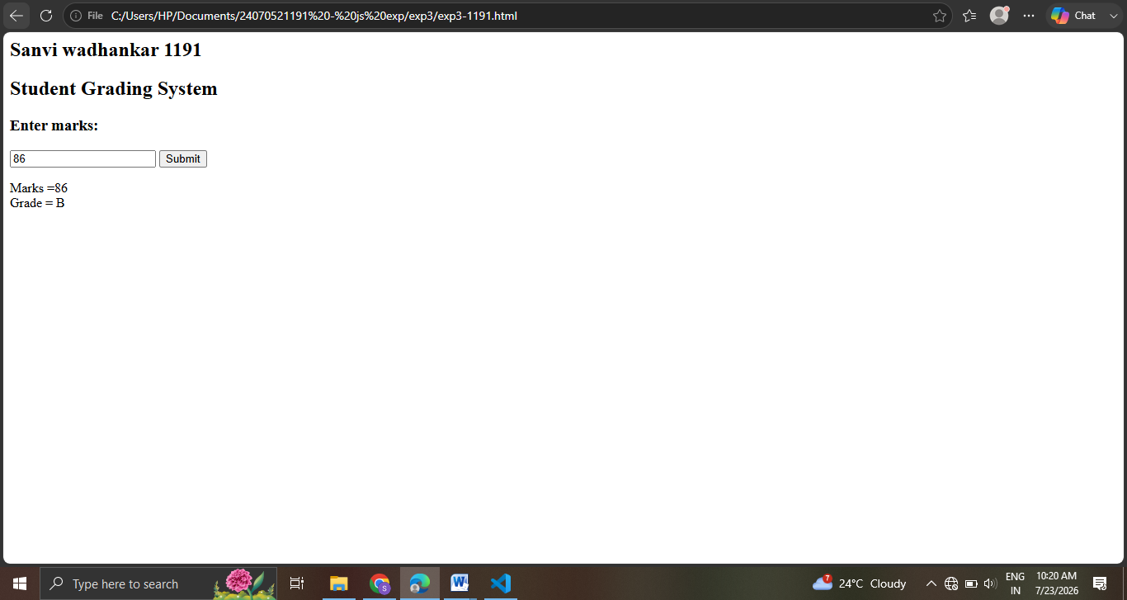
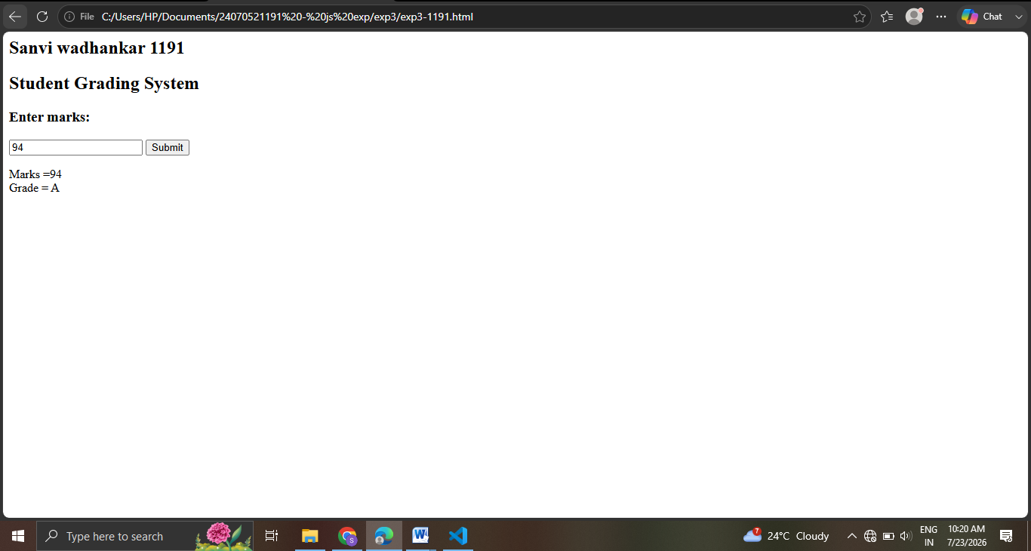
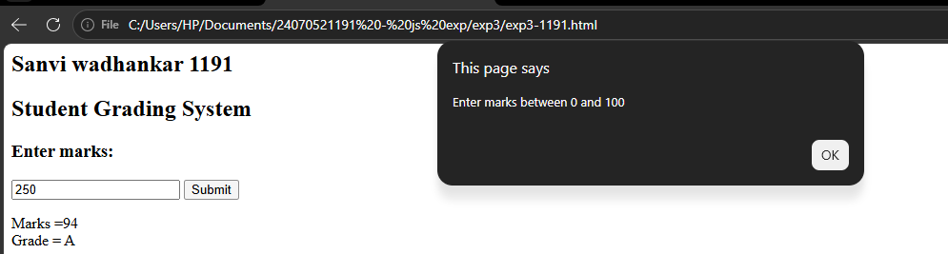

Case Study 03
Case Study Title:- Scholarship Eligibilty:
A college awards scholarship based on marks
Below 50:- Not eligible
50-69:- Bronze Scholarship
70-84:- Silver Scholarship
85-94:- Gold Scholarship
95-100:- Platinum Scholarship
Software/Tools Used:- VScode , Web Browser
Case Study Code:-
<html>
<head>
<title>Scholarship Eligibility</title>
<style>
body {
font-family: Arial, sans-serif;
background-color: #f2f2f2;
text-align: center;
padding: 40px;
}
h2 {
color: #c21321af;
margin: 5px 0;
}
input {
padding: 8px;
font-size: 15px;
margin-top: 10px;
border: 1px solid #c0e61b;
border-radius: 4px;
}
button {
display: block;
margin: 15px auto 0;
padding: 8px 20px;
font-size: 15px;
background-color: #1a5cff;
color: white;
border: none;
border-radius: 4px;
cursor: pointer;
}
button:hover {
background-color: #0d3fb0;
}
#result {
margin-top: 20px;
font-size: 17px;
color: #333;
}
</style>
</head>
<body>
<h2>Sanvi Wadhankar 2407051191</h2>
<h2>Scholarship Eligibility System</h2>
<h3>Enter marks:</h3>
<input type='number' id='marks'></input>
<button onClick="checkScholarship()">Submit</button>
<p id='result'></p>
<script>
function checkScholarship(){
var marks = document.getElementById("marks").value;
if( marks == ""){
alert("Please Enter marks!!");
return;
}
if(marks<0 || marks> 100){
alert("Enter marks between 0 and 100");
return;
}
if(marks>=95){
scholarship = "Platinum Scholarship";
}
else if(marks>=85){
scholarship = "Gold Scholarship";
}
else if(marks>=70){
scholarship = "Silver Scholarship";
}
else if(marks>=50){
scholarship = "Bronze Scholarship";
}
else{
scholarship = "Not Eligible";
}
document.getElementById("result").innerHTML =
"Marks = " + marks + "<br>Scholarship = " + scholarship;
}
</script>
</body>
</html>

Output:-
